**Interpret a Data Visualization**

Interpret a Data Visualization: LinkedIn Top Skills for 2016

By Victoria Perez Mola

# Introduction

This Project consists in report three insights using one Tableau Dashboard.

# About the Dashboard

This dashboard presents the top 10 skills of 2016, the visualization uses the LinkedIn’s annual list of the skills that employers need most in candidates and breaks it down globally and in 14 countries.

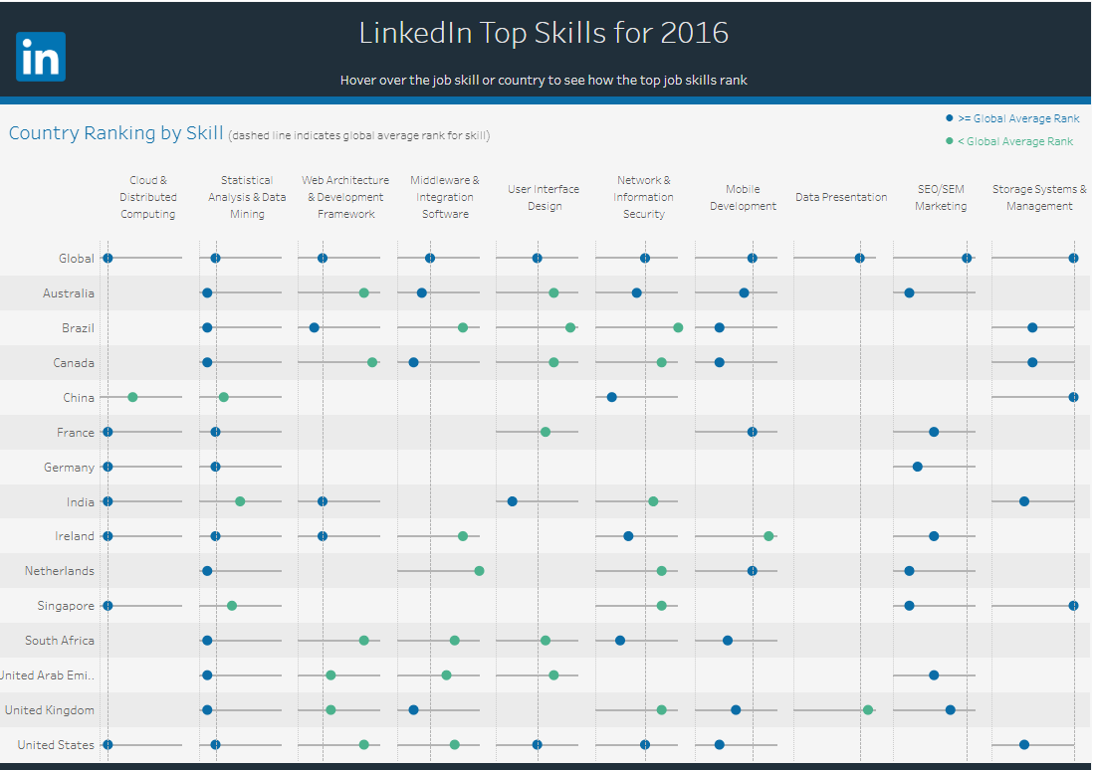

# Insight #1: United States has the most demanded skills

The United States is the country that follows the closest the top 10 skills.

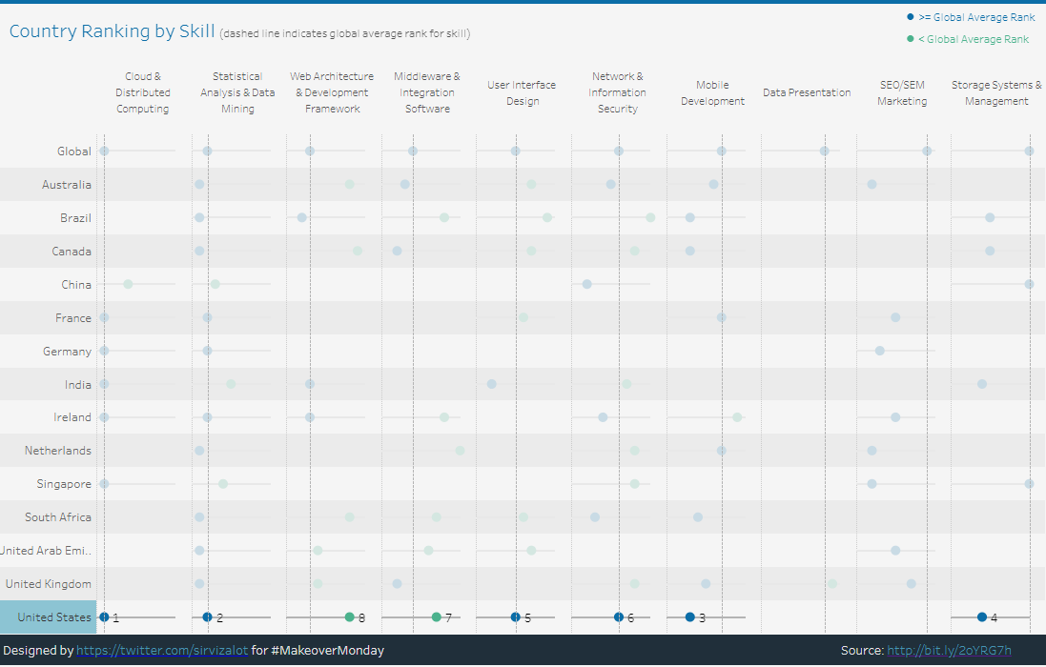

As seen in the screenshot, not only it has a presence in 8 out of the 10 skills, but also in 6 of them is equal or above the Global average. It seems to be the most visionary market above the presented dataset, could be related to be the home of Silicon Valley, a global centre for high technology and innovation.

I ran into this insight by clicking on each country at once, to highlight it’s rankings only and comparing the ranking on each skill against the average. By clicking on the United States, rankings can be seen in almost every column, unlike the rest of the countries and almost no green dots (below average) can be seen.

# Insight #2: Germany has a less adaptive market

Although Germany is not below average in any of the skills, it only ranks 3 of them: Cloud& Distributed Computing, Statistical Analysis & Data Mining and SEO/SEM Marketing. This can be seen in the following screenshot:

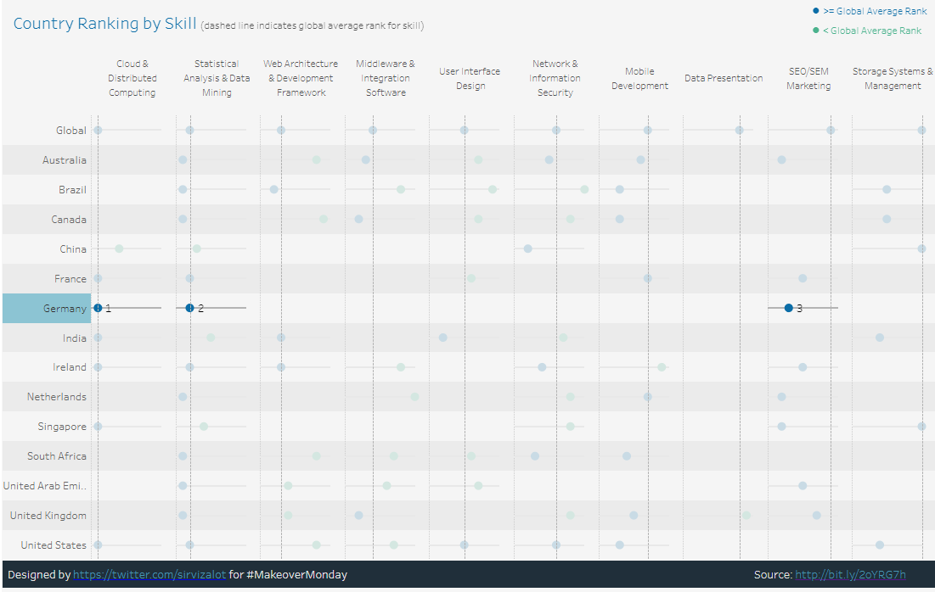

Additionally, they are above the global average when it comes to Marketing is a skill whose demand has been slowing compared with previous years.

Probably related to a more conservative market, less adapted to the latest trends.

I discovered this insight by clicking on Germany, it highlighted the relevant row and I could see that it had a very few dots. And what caught my attention was that in the Marketing column, the ranking had a big difference with the global average.

# Insight #3: Marketing and Storage Management are stabilized skills

SEO/SEM Marketing and Storage Systems & Management are the only 2 skills that have no countries below average. It seems to be skills that have reached a more stable level globally speaking. This trend can be seen even more with Marketing, where all countries are above the average. 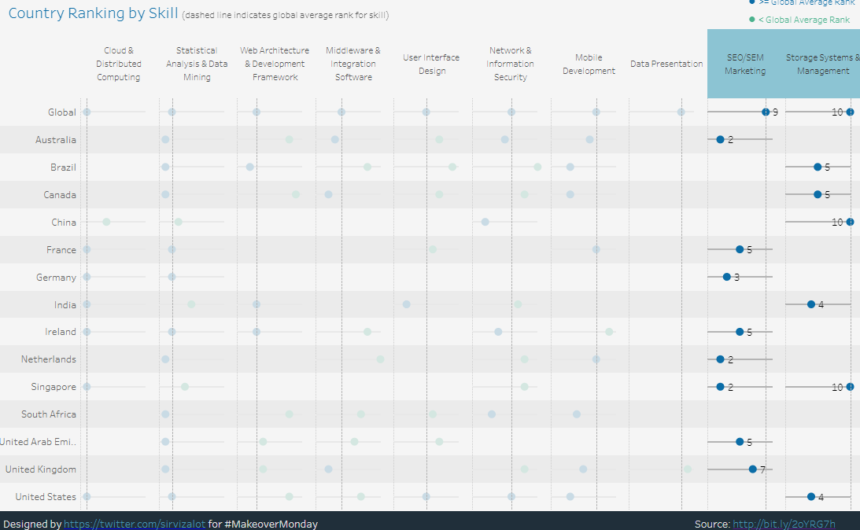

# Conclusion

The dashboard was simple and easy to understand at first sight and to see how the adaption of the skills can vary from country to country. While some countries seem to be more conservative, like Germany, where the presence of the top skills was low. Others are more on a trend setter path, like the United states, that had a presence in almost every top skill.

It was also clear how skills like Marketing, were more stable, having almost every country above the global average than other like Middleware & Integration Software where countries tended to be below the global average. This is also related to the changes in the skills demand compared to previous years, since Marketing had dropped in the 2016 from #4 to #9 compared to 2019.

I discovered this insight by clicking on each column, the two mentioned columns have no green dots, meaning that every country on the dataset has a ranking equal or above average.

# References

* [LinkedIn Unveils The Top Skills That Can Get You Hired](https://blog.linkedin.com/2016/10/20/top-skills-2016-week-of-learning-linkedin)
* [LinkedIn Top Skills Dashboard](https://public.tableau.com/profile/matt.chambers#!/vizhome/LinkedInTopSkills2016-MakeoverMonday/LinkedInTopSkills2016-MakeoverMonday)